

Point Of Sale System Project Preparation:

Ayham Fares Al Khalilah

Supervised by Eng. Bisharah Estephan

|  |  |  |
| --- | --- | --- |
| **number** | **Subject name** | **Page number** |
| 1 | **Chapter One: Introduction** | |
| 1.1 | Problem | 7 |
| 1.2 | The goal of the project | 7 |
| 1.3 | Tools and software used | 8 |
| 2 | **Chapter Two: System Life Cycle** | |
| 2.1 | System Analysis Goals | 10 |
| 2.2 | system design | 10 |
| 2.2.1 | System Participants | 11 |
| 2.2.1.1 | The primary webmaster | 11 |
| 2.2.1.2 | The Seller | 11 |
| 2.2.1.3 | The Procurement | 11 |
| 2.2.1.4 | The accountant | 11 |
| 2.2.2 | Data Analysis | 12 |
| 2.2.3 | Entity relationship diagram | 12 |

|  |  |  |
| --- | --- | --- |
| 2.1 | System implementation | 14 |
| 2.2 | Integration & Testing | 22 |
| 2.3 | maintenance | 23 |
| 3 | **Chapter 3: Discussion & Conclusion** | |
| 3.1 | Discussion | 23 |
| 3.2 | Conclusion | 23 |
| 3.3 | Recommendation & Reference | 24 |

**List Of Tables:**

|  |  |  |
| --- | --- | --- |
| **Table Number** | **Description** | **Page** |
| 1 | Users | 19 |
| 2 | Transactions | 19 |
| 3 | Items | 19 |
| 4 | User Transaction | 20 |

**List Of Figures:**

|  |  |  |
| --- | --- | --- |
| **Figure Number** | **Description** | **Page** |
| 1 | System Lifecycle | 9 |
| 7 | Logging in to the website | 14 |
| 8 | Home Page | 15 |
| 9 | Selling Dashboard | 15 |
| 10 | Edit transaction | 16 |
| 11 | Items Page | 16 |
| 12 | Edit Item | 17 |
| 13 | Create Item | 17 |
| 14 | Accounts Page | 18 |
| 15 | Transaction Page | 19 |
| 16 | Transaction Edit Page | 19 |
| 17 | Create User Page | 20 |
| 18 | Information User Page | 20 |
| 19 | Edit User Page | 21 |

1. Introduction

A POS system, is a computerized system that is used to process transactions in a retail or hospitality setting. The POS system typically consists of a computer, a cash register, a card reader. The POS system is used to process transactions by scanning or manually entering product information, calculating the total cost of the sale, and accepting payment. Some POS systems also include additional features such as inventory management, customer relationship management, and sales reporting. POS systems are used in a variety of settings, including retail stores, restaurants, and other hospitality businesses.

# Problem:

The purpose of a POS system project is to provide a tool that streamlines and simplifies the process of conducting transactions, managing inventory, and tracking sales and customer data. A POS system can help a business run more efficiently by automating tasks, providing real-time data, and reducing the risk of errors or fraud. It can also help businesses better understand and serve their customers by providing insights into sales trends, customer preferences, and other data.

# The goal of the project:

The goal of a POS system is to improve the efficiency and accuracy of sales transactions, streamline business operations, and provide useful data and insights for decision making. Some specific goals of a POS system may include:

* Reducing the time and effort required to process transactions for staff.
* Providing real-time inventory tracking and management.
* Improved accuracy: POS systems allow businesses to accurately track sales and inventory, reducing the risk of errors and discrepancies.

# Tools and software used

Technical Feasibility Our system is a web-based application and the main technologies and tools that are associated with this project are:

1. For Front-end we will use:
   * HTML
   * CSS
   * Bootstrap
   * JavaScript and jQuery 2- For Back-end we will use:
   * PHP
   * MySQL
   * Xampp Server
   * Ajax and JSON
   * Rest APIs

System life cycle

Each system has a life cycle (System Development Life Cycle), through which the system is built and developed based on sequential stages, as shown in Figure (1):

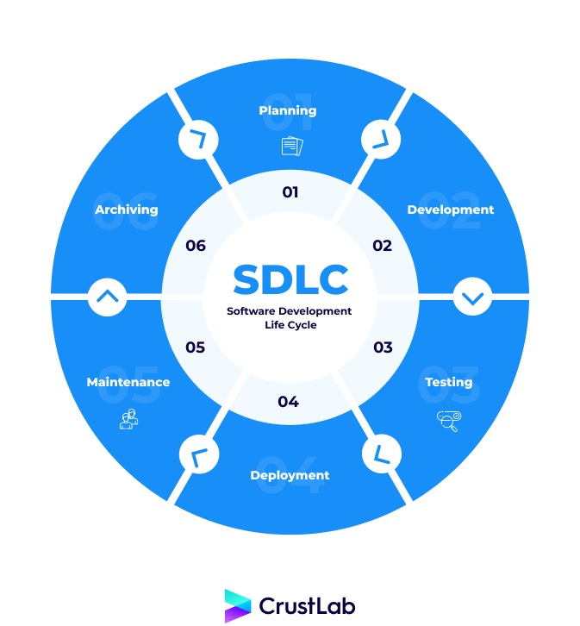

Figure 1: System Lifecycle (SDLC)

# System Analysis Goals:

By performing a system analysis, we were able to accomplish several objectives, including:

* + - Identifying and understanding the current state of the system.
    - Determining the requirements for a new or updated system.
    - Identifying potential solutions and alternatives.
    - Evaluating the feasibility and cost-effectiveness of potential solutions.
    - Testing and evaluating the new or updated system.

# system design:

Identify the requirements: Based on the problem definition and analysis of the current system, the next step is to identify the specific requirements of the new system. These requirements may include functional requirements (what the system should do), performance requirements (how fast the system should operate), and non-functional requirements (such as security, reliability, and usability).

Design the new system: Once the requirements have been identified, the next step is to design the new system. This may involve creating a high-level design, which outlines the overall architecture of the system, and a detailed design, which specifies the individual components and their interactions.

Implement the system: The final step in the system design process is to implement the new system. This may involve writing code, building hardware components, and testing the system to ensure that it meets the requirements.

Overall, the goal of the system design process is to create a system that is efficient, effective, and meets the needs of the user.

# System Participants:

The system consists of four main parties: 1- Admin

1. Seller
2. Procurement
3. Accountant

# Admin:

The administrator has the authority to control all of the system:

* + - * 1. Modify and delete transactions from the account page.
        2. Adding, modifying and deleting system users.
        3. Adding, modifying and deleting items.
        4. Adding, modifying and deleting transactions.

# The Seller

The Seller has total authority over the Selling dashboard:

* + - * 1. Adding, modifying and deleting transactions.

# The Procurement

The Stocks dashboard is completely under the control of Procurement.

1- Adding, modifying and deleting items

# The Accountant

The Transaction Dashboard is completely under the control of Accountant.

* + - * 1. Modify and delete transactions from the account page.

# Data Analysis:

In a point-of-sale (POS) system, data analysis can be used to track sales, identify trends and patterns, and optimize inventory management. POS systems often generate a large amount of data, including information about customer purchases, product details, and sales staff performance. By analyzing this data, businesses can make informed decisions about marketing, pricing, and other key aspects of their operations.

* Create a database schema: which includes tables for storing information about items,

users, transactions, and any user-transactions.

* Create the models: The models in an MVC application represent the application's data and business logic. You could create models for products, customers, and transactions for a POS system.
* Plan the POS system's functionality: Determine the features and capabilities that you want the POS system to have. This could include inventory management, transaction processing, report generation, and other tasks.

# Entity relationship diagram

The entity relationship diagram is depicted in Figure 6.

Figure 6: Entity Relationship Diagram

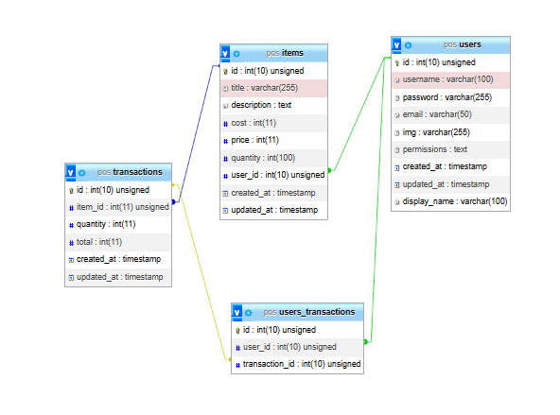

Database and system page design:

The system includes the following primary tables:

Table 1: The Table Users

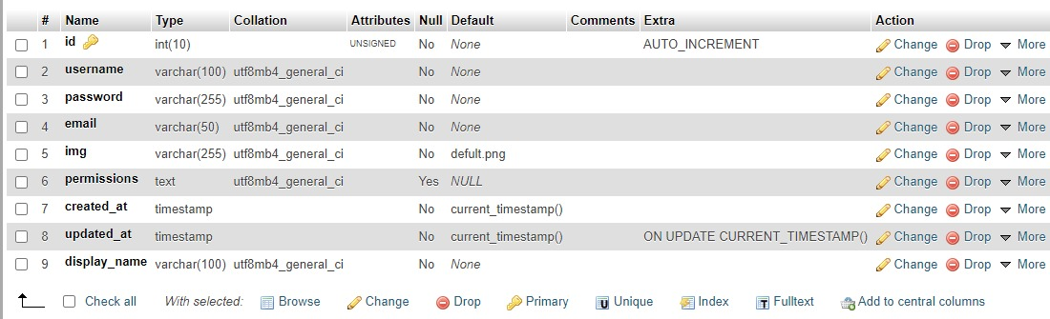

Table 2: The Table Transactions

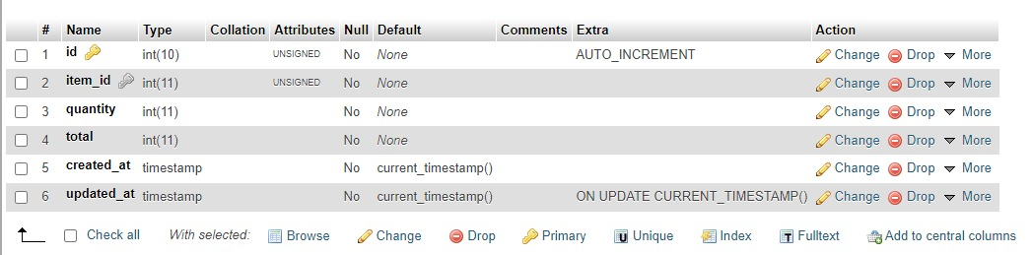

Table 3: The Table Items

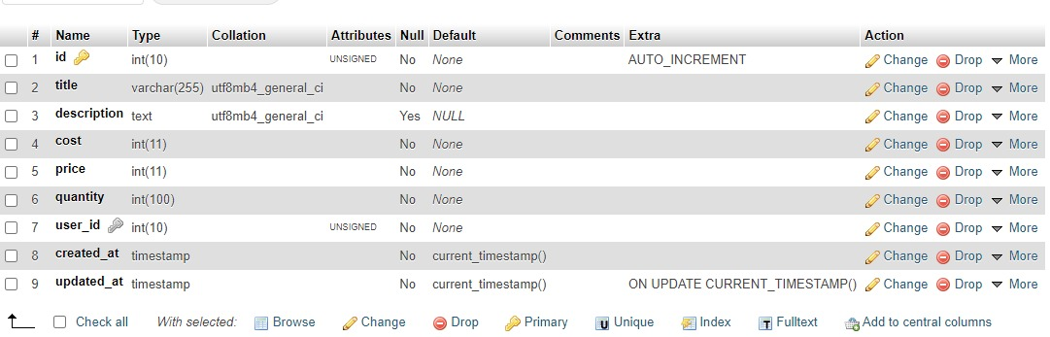

Table (4): Relationship table between the transaction and the user

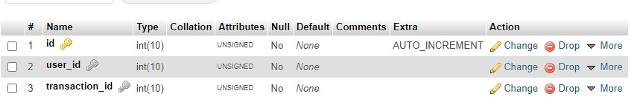

# System implementation

After depending on the system's analysis and design stages, the implementation stage builds the whole system's components, including pages and lists, so that all of the system's pages are presented and the function of each page is explained separately. The website is meant to be easy and adaptable in order to suit the demands of all users.

Login page for the website:

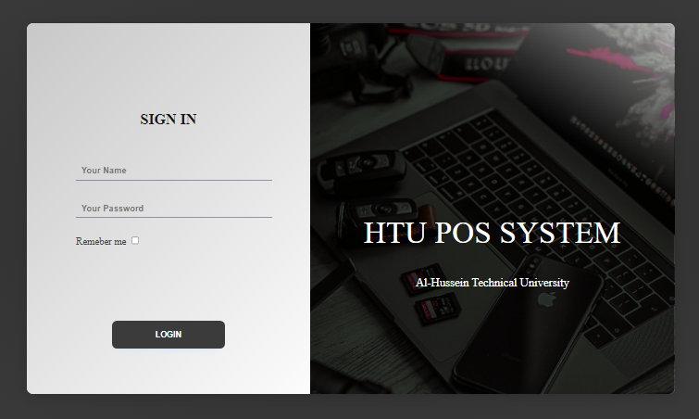

Figure 7: Logging in to the website

This screen displays a form with two components (username and Password), a login button, and a verification button (REMEMBER ME). Its purpose is to save the (User-id) when you return to the site. It is the initial page the user encounters. It was developed in a basic and adaptable manner, with no complication, and from here the user may log in to the site.

Dashboard:

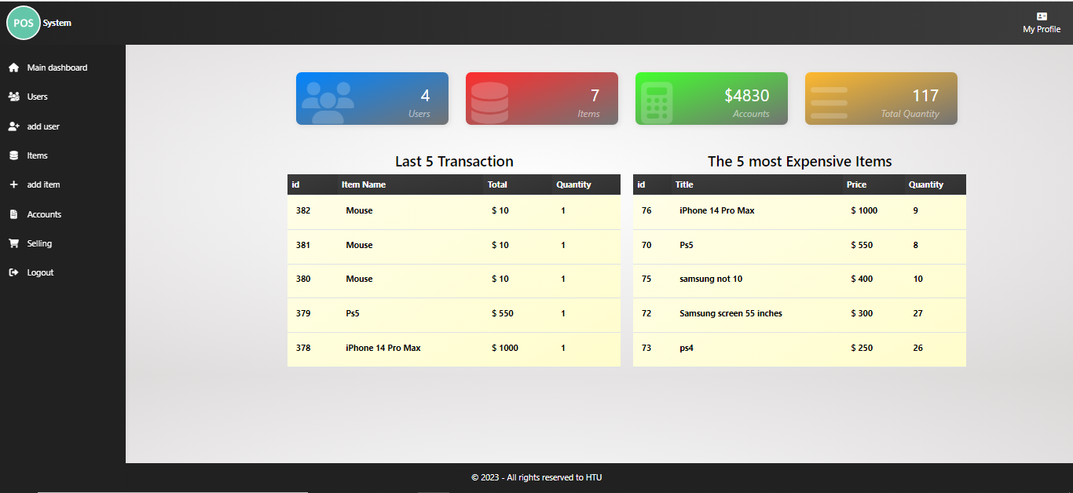

Figure 8: Home Page

The system's core categories and certain information are presented on the system's main page, such as: Total Sales, Total Transactions, Total Items, Total Users, Total Quantity, Total Profit, Top Five Expensive Items.

Selling Dashboard:

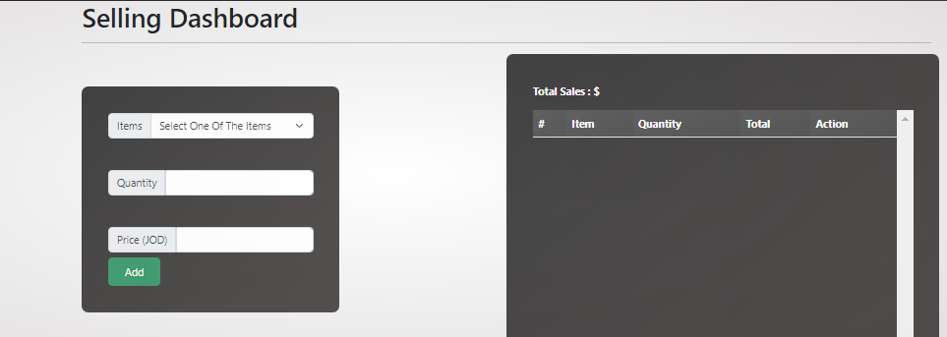

Figure 9: Selling Dashboard

This page lists all of the things in the store that are currently for sale. the seller can pick the quantity desired and hit the add button and show table from the bottom page which displays all of the sales made by the user today, and the button delete and update transactions.

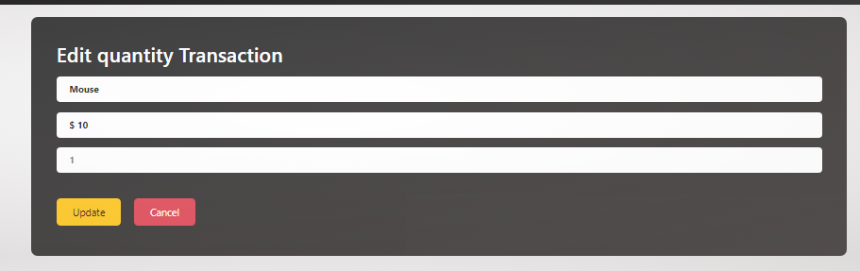

Figure 10: Edit Transaction

This page contains the information of transaction id and you can update this transaction quantity Either increase or decrease, and update item quantity from table item.

Items page:

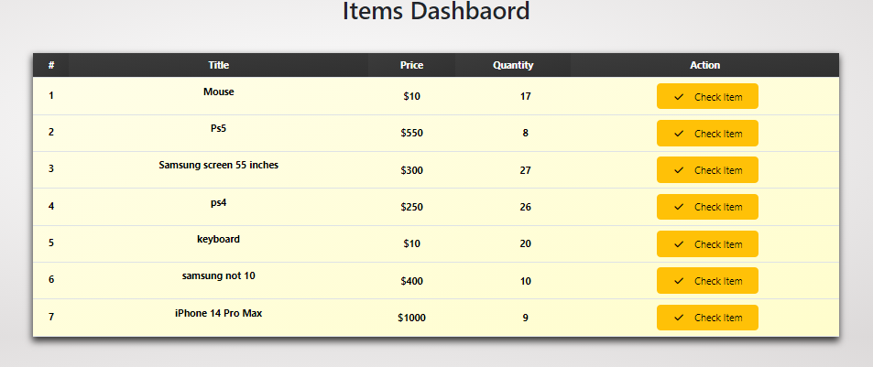

Figure 11: Items Page

The screen page allowing you to see how many things we have in stock as well as information about each product, such as cost, pricing, and quantity. There are also two buttons for each item, the first of which allows you to alter the product and the second of which allows you to delete the product.

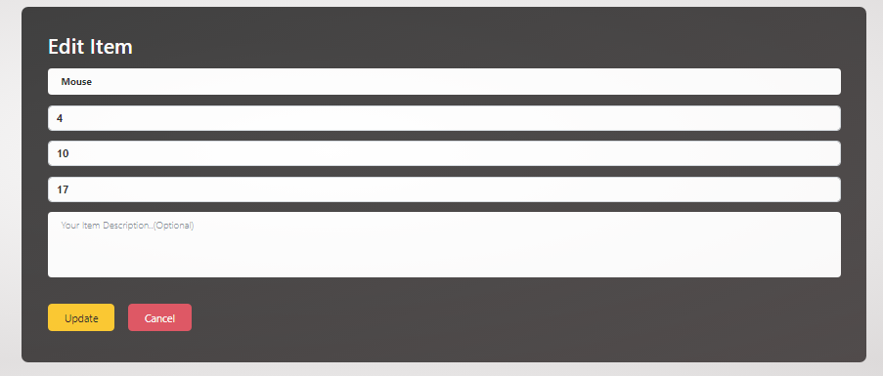

Figure 12: Edit Item

This page is about modifying the product, through which we can amend the product name, price, cost, or quantity, and modify the description.

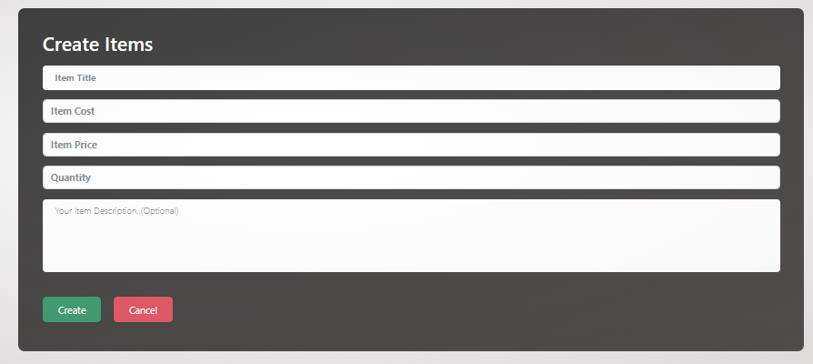

.

Figure 13: Create Item

This screen page shows the form that can create new item by input title item and quantity and cost and price and the description is optional when you user needed added description to item.

Accounts Page:

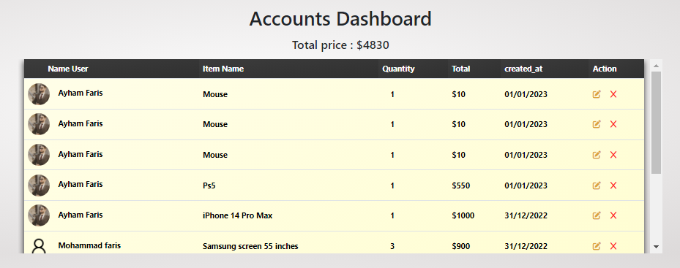

Figure 14: Accounts Page

This page is for the accountant to see all of the sales transactions that have occurred, as well as the name of the seller, the name of the product, and the amount sold by the seller. Each process also has two buttons, the first of which allows you to modify the sale process and the second of which allows you to remove the process.



Figure 15: Transaction Edit Page

The accountant may adjust the quantity of a certain sale without changing the name or the

price item, and as soon as the amount changes, the total changes automatically.

Users Page:

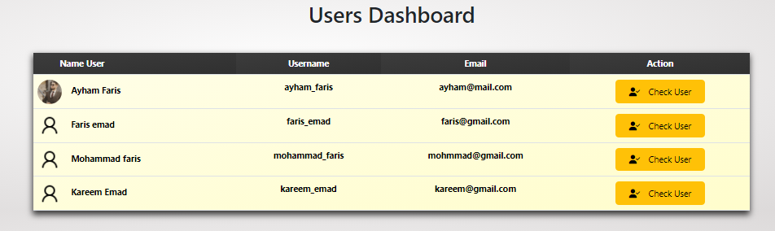

Figure 16: Users Page

This page is for the site management, and it allows them to see the number of users on the site as well as the powers of each user, as well as the check me button for each user, which provides particular information for each user.

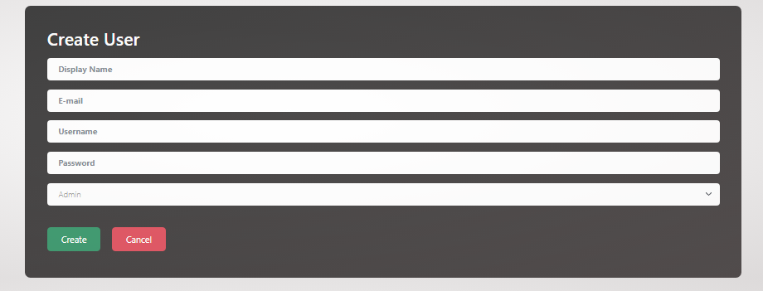

Figure 17: Create User Page

This page allows the site administrator to add users and delegate authority to them, such as an

accountant, seller, or admin, procurement.

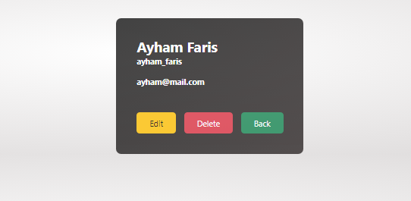

Figure 18: Information User Page

Through this page, the system administrator may view the information for each user, and there are two buttons, the first to adjust the user's privileges, and the other to limit the user.

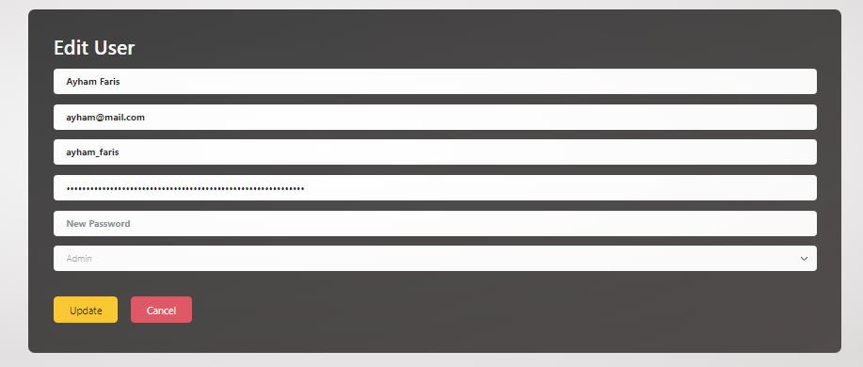

Figure 19: Edit User Page

This page is intended for the system administrator and the user but the user lacks the permission function, which allows the system administrator to update the user's information, his role in the system and even the user's photo. The user can only modify their personal information, such as their photo, name.

# Maintenance

The tasks necessary to guarantee that a software system continues to perform as intended are referred to as maintenance in software development. This can include bug fixes, new features, and hardware and software upgrades. Maintenance is an essential component of the software development life cycle (SDLC) since it helps to guarantee that the program stays dependable, efficient, and effective over time. The particular maintenance tasks carried out within the SDLC will be determined by the software system's requirements and the resources available to maintain it.

# Conclusion

In conclusion, our analysis of the POS (point of sale) system revealed several key findings. Our research indicates that the system is efficient in processing transactions, with a low average transaction time. Additionally, the system is user-friendly, with a simple and intuitive interface that is easy to navigate. The system's inventory management feature is also found to be robust and effective, allowing for easy tracking of stock levels and reordering. Overall, our analysis suggests that the POS system is a streamline the sales process, provides valuable data, and allows for efficient inventory management. We recommend the system for any business looking to improve their sales process and gain valuable insights into their operations.

# References

# <https://www.w3schools.com/>

# <https://www.phpmyadmin.net/>

# <https://www.google.com/>

# <https://www.php.net/>

# <https://www.youtube.com/>

# https://fonts.google.com/

# https://bootstrapdocs.com/